ANNEX 1

INVEST LOCAL
PLAS MADOC
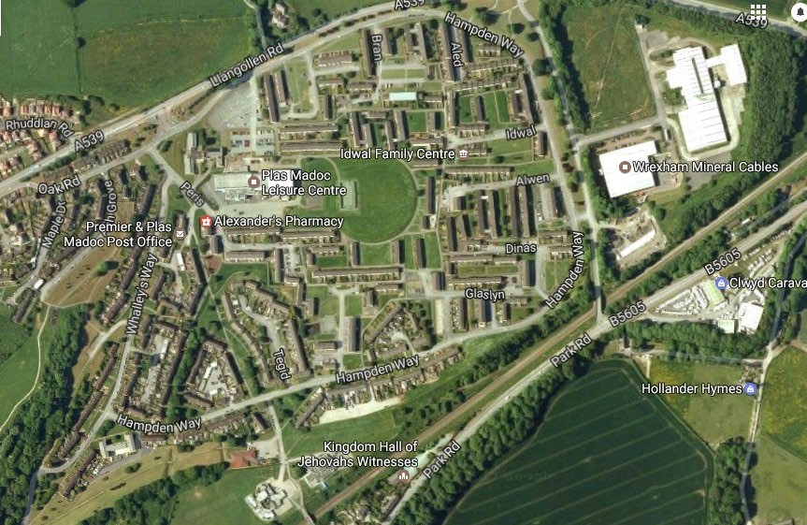
DRIVING CHANGE PLAN 2 MAY 2021

Contents
Section | Page number
1. Background - Community Profile | 3-5
- Introduction  - Community buildings, facilities, groups and ac  - Key facts about Plas Madoc | tivities
2. The story so far… what’s happened | 6-8
3. What we’ve learnt | 8-9
4. What do people in Plas Madoc think now? | 9-11
5. Responding to the consultation and planning for the future | 11-15
6. Plan proposal | 16-17
7. Budget | 17
8. What would be needed to achieve our vision and aims? | 18-22
9. How will we know if we’re successful? | 22-24
10. Appendix 1 – WAPM Ludicology findings - full report | Attached PowerPoint document
11. Appendix 2 – PM 2nd consultation questionnaire | Attached word document
12. Appendix 3 – Community consultation 2020 additional comments | Attached excel document
13. Appendix 4 – WAPM Manager Job Description and agreement | Attached word document
14. Appendix 5 – Community Development Worker - Job Description | Attached word document

1. Background - Community Profile

Introduction
Plas Madoc is a large housing estate on the outskirts of Wrexham. It has a clearly defined boundary and several nearby villages – Rhosymedre, Cefn, Ruabon, Acrefair. There are regular buses to Wrexham, Llangollen, and Oswestry. It is also just up the road from Pontcysyllte Aqueduct.

Community buildings, facilities, groups and activities
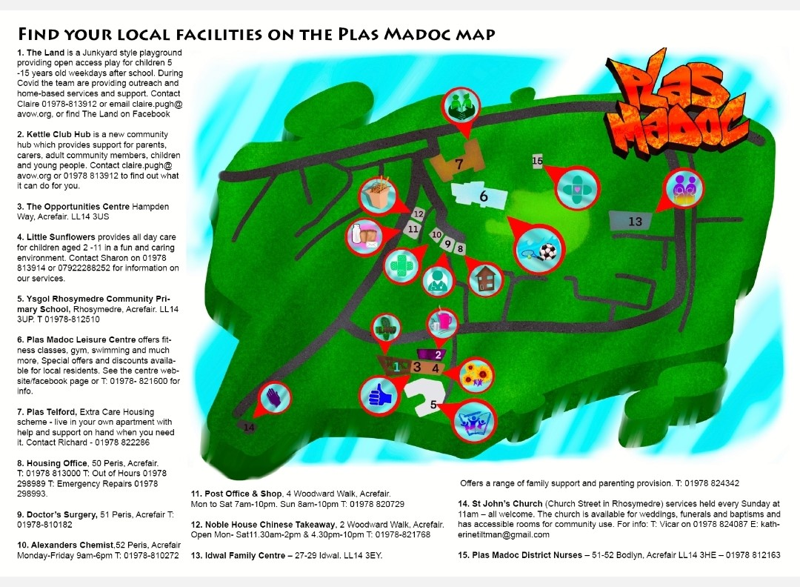

Key facts about Plas Madoc 2021

Population: 2,069 (estimate) Here is the population broken down into ages:
Age | No | %
0-9 | 449 | 22
10-19 | 280 | 14
20-29 | 343 | 17
30-39 | 253 | 12
40-49 | 207 | 10
50-59 | 184 | 9
60-69 | 140 | 7
70-79 | 132 | 6
80+ | 81 | 4

The age of people in Plas Madoc is far younger than the Welsh average.
The proportion of males is a little higher than the Welsh average at 52% of population. This likely due to young population as women live longer (more women at older age groups)
Housing: 17% of homes are privately owned (far less than the Welsh average)
Most homes are socially rented (local authority owned)
Housing: 10% of population are live in overcrowded accommodation compared to 6% in Wales. Although only 1% is likely to be in a state of disrepair compared to 3% in Wales.
Transport: 50% of people have no access to car (far less than the Welsh average)
Poverty: 39% population are in poverty (income deprivation) compared to 16% in Wales
Child poverty: 42% of children live in poverty (around twice that of the Welsh average)
Online access: In contrast to Wales the availability of broadband is good with full coverage in Plas Madoc.
Environment: The quality of the local environment is fairly poor due to risk of flooding.
Crime: Crime rates are higher than the Welsh average although the difference has decreased. For example criminal damage used to be three times higher (2016) than the average, now it is only marginally different.
Health: The health of residents is worse than in the whole of Wales, with around 32% of people suffering from long term illness compared with 23% in Wales.
9% of babies in Plas Madoc are born underweight – across Wales the figure is 6%
Average Time to travel to local GP is good i.e. 20 minutes compared to 40 minutes in Wales.
Education: 38% of adults (aged 25 – 64) have no qualifications, almost twice Welsh average.
Pupil attainment in Plas Madoc at Primary School is similar to the Welsh average.
About 7% of young people (aged 18-19) in Plas Madoc attend Higher Education; across
Wales the figure is around 30%
Employment: 20% of the working population are in employment deprivation (involuntary excluded from work i.e. unemployed or can’t work due to ill health), this is twice as much as the Welsh average.

2. The story so far… what’s happened
In 2016/17 we - the Plas Madoc Invest Local steering group (now known as We Are Plas Madoc – WAPM) held a series of events to engage residents in identifying priorities for the Invest Local program.
192 responses were analysed and the following 6 themes identified:
- Community Spirit and Sense of Security
- Play Provision for Children and Teenagers
- Local Leisure Activities
- Improving the Public Realm
- Accessibility of Local Services
- Education and Jobs
A follow up event with residents tested these themes and provided them with an opportunity to apportion a representative sum of money across these priorities.
Using action planning sessions (based on the consultation findings) the steering group created a vision for the Invest Local programme and a set of priorities to form Plas Madoc’s first Driving Change plan.
VISION:
Plas Madoc will be confident and proud with excellent community spirit. The people of Plas Madoc will know and look after each other, they will support each other so they can be involved. Plas Madoc will be a community where people like to live and where people feel safe and secure.
Priorities:
- Support Plas Madoc Leisure Centre (PMLC) to stay open by reducing costs and increasing income
- Develop PMLC as a community hub (and possibly the Opportunities Centre)
- Explore the possibility of setting up a Timebank
- Support a wider range of regular events & activities
- Retain playwork provision and further develop opportunities for children, teenagers & families
- Better communication
- Organisations working together

So what’s happened during the three years of that Driving Change Plan?
A lot! As you’ll see in the below table:
Priority: | What we did:
Support PMLC to stay open by reducing costs and increasing income | £100,000 of Invest Local money used to buy new boilers for the Leisure Centre (this avoided the very near crisis of them having to close)
Develop PMLC as a community  hub (and possibly the Opportunities Centre) | WAPM are working with PMLC to adapt a space within the Leisure Centre to be a space for community activity, and are also working together on food projects/café. The Land have also been successful in accessing funding to buy a container which is now home to the Kettle Club Hub – a support hub and home to Kettle Club (an informal parent support group).
Explore the possibility of setting up a Timebank | Timebank option was not taken up at the time, and a Community Development Worker was employed instead to do direct engagement work. Time credits are now being accessed by volunteers via a Welsh Government funded scheme.
Support a wider range of regular events & activities | Large scale seasonal events have been held each year, along with a variety of smaller regular activities. The larger events act as an opportunity for the community to come together, socialise, celebrate, and a space for WAPM to continue to consult with the wider  community. Since the employment of the Community Development worker WAPM has had much more  capacity to facilitate smaller more regular events. These are supporting residents to build confidence, social networks, and become empowered and active citizens. They both allow for community spirit and pride to be built on.
Retain playwork provision and further develop opportunities for children, teenagers & families | 3 years funding for the Land (Play and Community Development project) which covered the projects costs, including 3 core staff. This investment has seen the Land being able to focus on Plas Madoc, which has meant more and varied provision for children and young people, more support to families, and more community development work. The Land has been a key part of enabling and facilitating WAPM’s Driving Change plan to happen.
Better communication | With the employment of the Community Development Worker WAPM has had much more capacity for better communication. This has meant regular newsletters, a number of active facebook pages, and a website.
Organisations working together | The coming together of local organisations within the structure of the steering group, has seen local organisations working together much more. This has resulted in them being able to do more and better.

COVID-19
We can’t talk about these past few years without mentioning (unfortunately!) COVID 19. However, the silver lining to this has been our community response to the pandemic and subsequent lockdowns. As a group, and staff in particular, we have adapted well and worked very hard over the last year or so, responding immediately to support our community with access to the essentials and support with activity packs, materials for making the most of your outside space (e.g. planter, benches), online activities, support over the phone, and when possible street play. We have in fact engaged with a lot more people and recruited street champions to act as volunteers sharing information with their neighbours. It has in fact highlighted the strength of our networks that we have been building and the level of community spirit we have.
As a group (on the whole) we have also adapted very well to meeting on Zoom, and have actually managed to attract a few new members, as Zoom makes it more accessible to them. We’ve even managed to do some difficult planning sessions online, this really has shown us how we’ve developed and strengthened as a group over the past 4 years, and hence our ability to work so well together. But we do look forward to when we can start to meet regularly in person now, with some people on Zoom!

3. What we’ve learnt
As I’m sure you can imagine, a lot! Last summer we commissioned Ludicology to help us with reviewing and planning for the future (See Appendix 1 for Ludicology’s full report). Here are the conclusions from the Visioning workshop we took part in, as part of the review and planning exercise:
- If all the funding ran out today, WAPM already has a legacy to be proud of.
- That legacy is about the fostering of non-material assets (community spirit, sense of safety, trust, pride, belonging, relationships) aligned with the group’s vision / aim.
- To maintain and further develop these non-materials assets, WAPM has invested and should continue to invest in the material assets that makes these things possible.
- WAPM’s core assets are the people involved, the staff and volunteers that make things possible and the people who participate in the activities of WAPM and its partners.
- WAPM is developing a culture of engagement and involvement, enabling people to participate in the life of Plas Madoc but this ongoing participation needs an infrastructure to support and deliver it.
- There is also more work to do to harness the potential of all this participation. WAPM can be the platform that enables residents to influence what happens in their community.
- WAPM has benefitted greatly by investing in and sustaining existing partner organisations who hold significant assets but also carry associated liabilities.
- Further enhancing WAPM’s legacy requires maximising existing assets without significantly increasing liabilities; working with partners to increase activities/events as a vehicle for engagement.
- WAPM currently has a relatively cost-effective and sustainable model. Most liabilities are carried by others, WAPM’s only material assets are staff, these staff generate more assets by involving more people, that generates all the non-materials assets which is WAPM’s legacy.
- WAPM, as a network organisation, can further enhance the assets of this network by developing new and existing partnerships.
- Investing time in working with Splash to negotiate terms and develop a community hub at the leisure centre would be more cost effective than paying for a new building.
- It is also important to consider how much more money WAPM’s existing investments have generated for services within the community.
- WAPM needs a staffing infrastructure with sufficient capacity, experience, knowledge and networks to maintain and develop the participation offer. That means more than one person.
- WAPM gets a whole lot more from the partners that just that which it officially funds. This is particularly true of The Land, which has been central to the success of
WAPM.
- Referring to this team as 'The Land’, misrepresents the contribution they are making to the work of WAPM.
- It makes sense to use the Invest Local funding to fund the things that you see as important / essential to your aims and which are not being sufficiently funded through other means.
- There is potential for WAPM to renegotiate what it funds partners for to better recognise the contribution they are making and secure the support WAPM requires.
- WAPM can work with partners to enable them to access further funds but for that to happen they need to be provided with solid foundations and sense of security.

4. What do people in Plas Madoc think now?
As mentioned above last summer we started reviewing and planning for the future, because a) the first plan was coming to an end in December 2020, and b) The Land project was pulling together a 5 year funding bid to the Lottery’s People and Places fund and needed to know how WAPM wanted to continue to work with them if they were successful with the bid, and if they weren’t. As a result we decided we needed to go out to consult with the

wider community on the existing and ongoing priorities, and some new possible priorities which had started to develop through their work.
During August 2020 we consulted via a paper survey posted to all houses on the estate via the street champions (local volunteer residents). The street champions knocked on doors to offer support with completing the survey via a conversation and scribing or to leave the survey with residents for collection later on. The survey was also put on survey monkey and advertised using various community Facebook pages. The group received 180 responses.
As you’ll see from the table below containing these responses the survey confirms that (amongst those who responded) the vast majority of residents support the delivery, development and funding of WAPM’s existing activities/services.
The survey also confirms that the vast majority of residents are broadly supportive of the new ideas presented by WAPM.
These survey results give WAPM confidence and permission to continue in a similar direction of travel. The results serve to re-enforce the ideas and priorities of our group.
See Appendix 2 for full questionnaire.
Consultation questions | Yes | No
Would you like WAPM to work with the Leisure Centre to create a Community hub? | 88% | 12%
Would you like WAPM to help The Land with funding to keep it open? | 91% | 9%
Would you like WAPM to continue big community events? | 92% | 8%
Would you like WAPM to continue smaller events? | 88% | 12%
Would you like to be kept updated via Facebook, Newsletters, website? | 89% | 11%
Food projects - access to affordable fruit and veg bags, cooking projects, community café. Are any of these important to you? | 94% | 5%  Plus 1% not important
Gardening projects - community allotments, shared gardens, a community garden centre. Are any of these important to you? | 80% | Not sure – 9%  Not important  – 11%
Support services - support and advice on money, your rights, where and how to get help, tenants and | 89% | Not sure – 5%
residents association, recycling clothes projects. Are any of these important to you? |  | Not important – 6%
Do you have anything else you would like to share with us? Any comments or ideas you have - we would love to hear them so please tell us. | 132 comments – these will help form direction of WAPM’s work

See Appendix 3 for responses to final above question.

5. Responding to the consultation and planning for the future
During the consultation, as mentioned WAPM employed Ludicology. This was to also analyse the data from the consultation along with support with the reviewing and development of WAPM’s work and future. This involved interviews and workshops with people actively involved in WAPM and resulted in the production of a set of 13 recommendations. Again see Appendix 1 for Ludicology full report.
WAPM have adopted the recommendations and have subsequently held several sessions working through each of the 13 recommendations, proposing actions for each one:
WAPM actions in response to the recommendations presented by Ludicology
- Recognise ongoing participation as the strategy for achieving WAPM’s shared vision.
Make this the basis of WAPM’s action plan and invest in services/organisations/events/activities that enable the realisation of that plan.
  - Develop a participation strategy that explains how WAPM will go about developing a service offer that enables everyone to participate in activities and decisions, and helps to further/deepen that participation
  - Map what is already available, who is already participating and how often • Identify gaps and any duplication in service provision and sectors of the community
  - Speak to different group of people to find out how they would like to participate.
  - Develop solutions to address those gaps and identify ways to enhance participation
  - Produce the draft action plan
  - Strategy and action plan to be jargon free, easy to access and possibly with pictures.
- Introduce annual monitoring requirements for funded services/organisations enabling reporting of how activities contribute to WAPM’s participation strategy.
  - Identify and agree a consistent set of performance indicators for all WAPM funded or delivered activities that align with the outcomes of the participation strategy
  - Produce a standard feedback survey to be completed by participants at the end of each activity or annually
  - Collect bi-annual monitoring returns for all WAPM funded or delivered activities
  - Input participation data and feedback into a service mapping document
  - Discuss participation data with WAPM members on a bi-annual basis to identify what more is required
- Develop an investment strategy which seeks to maintain the realised potential of welldeveloped assets, further develop the potential of newer initiatives and explore the potential of un-developed opportunities.
  - Or in other words… how do we maintain what is already good, further develop things that look to be working well and retain some funding to explore other opportunities?
By…
- Invest up to two thirds of the remaining Invest Local funding over five years in maintaining the staffing and associated organisational infrastructure that supports WAPM; also allocate an annual budget to fund small and large community events.
  - Invest £306k over five years in two strategic and operational community development workers to create a staff infrastructure to maintain and develop existing initiatives.
And…
- Retain further funding to be invested in response to identified gaps in provision and for other innovations down the line in response to ideas from other residents who become involved.
  - Maintain an events budget (for delivering events)
  - Retain a small grant innovation budget (for supporting residents ideas)
  - Retain a budget for further service developments (application process)
  - Retain budget for investing in sustainability initiatives
  - Prioritise and applying for external funding when gaps in service delivery are identified – how many applications per year?
  - Create a dedicated committee to explore fund-raising and sustainability investment opportunities and/or committee to sustain provision / events beyond invest local such as Plastonbury
  - To explore the 5 ideas for potential future income generation to ensure the sustainability of WAPM’s work post Invest Local. Feasibility studies to commence
April 2021 to look at the following income generating ideas -
· Garden furniture – based on the experience of the Land during covid – potential for a contracted service working with NEETs/unemployed people and/or more commercial sales
· Garden Centre – building on Plants Madoc/the Land’s furniture work and the greening/environmental project work being undertaken by WCBC – and the fact that there is a piece of land which might be fit for purpose
· Community energy project – potentially involving solar panels on the Leisure Centre roof and/or other opportunities to be explored This could also involve setting up a bulk buying energy scheme
· Food Pantry – developing a food share scheme (such as that in Ellesmere Port) in partnership with the Leisure Centre and Clwyd Alyn(?)
- Work with AVOW to negotiate a new service level agreement for the Play and Community Development Team, clarifying the roles and responsibilities of individual staff who provide strategic and operational support to WAPM. In doing so provide this team with sufficient core funding so that they can secure additional grant funding to maintain and expand their service offer.
  - Invest £306k over five years in two strategic and operational community development workers to create a staff infrastructure to maintain and develop existing initiatives. This will include maintaining the level of quality of provision for children and young people through The Land and Playwork.
  - Develop job descriptions and identify key duties for strategic and operational roles, including clarifying reporting mechanisms and line management responsibilities. • Support the implementation of the 5-year Lottery bid ‘The Land – Play and Community Matters’ as a core element of WAPM’s participation strategy. The key deliverables are detailed below although further developments have happened since the 1st stage People and Places application was submitted.
    - The Land o Playschemes o Youth club o Youth forum o Other recreational activities for C&YP o Food projects o Kettle Club o Brunch and Munch
    - NEETS projects and unemployed people – building on the work of the benches / planters etc
    - Plants Madoc – environmental/ gardening projects o Regular participation opportunities i.e Bingo, Movie Nights etc o ‘Big’ community events i.e Plastonbury / Bonfire night o Intergenerational work o Volunteering opportunities and further developing Street Champions o Community hubs o Partnership forum - o Social enterprise / income generating projects.
- Work with Splash Community Trust to develop a partnership agreement that sets out how the two organisations can work together to compliment the work of each other and best support the community of Plas Madoc. Use this agreement as the basis for developing and investing in a community hub at the leisure centre.
  - Key questions - Why does WAPM need a community hub, food project and café? What is the vision? What will these spaces be used for? How does WAPM envisage these things operating and being used? How is that different to what happens now? What additional responsibilities / liabilities will this create? What are the practicalities?
  - Seek to develop a memorandum of understanding with Splash Community Trust setting out both parties’ commitments to working together to develop initiatives for the benefit of the Plas Madoc community and protocols for ensuring consistent communication and transparency between both groups.
  - WAPM and Splash Community Trust to co-commission a feasibility study exploring the benefits and risks for both parties of developing dedicated spaces for WAPM activities within the leisure centre.
  - Follow this with specific actions about developing the community hub and/or specific elements like the food project, café and meeting space, for example:
    - WAPM to take responsibility for a dedicated space within the leisure centre, which is available for use at any time the leisure centre is open, specifically for WAPM activities.
- Seek to establish new working partnerships with Rhosymedre School and Plas Telford, working together to create more participation opportunities across the network of WAPM.
  - Liz (Head) from Rhosymedre School and Eluned from Plas Telford have already joined WAPM to continue to maintain and further develop these relationships.
  - Consider developing a member role description / duties – a community pledge.
- Carefully consider the appropriateness of paid staff becoming trustees of the new legal entity and have clear protocols in place to avoid any perceived conflicts of interest in decision making processes.
  - Completed
- Develop a communication strategy identifying all WAPM’s channels of communication, who is responsible for maintaining them, how often they should be utilised and, most importantly, their purpose.
  - Produce a combined communication and participation strategy
  - Develop a communication strategy identifying all WAPM’s channels of communication, who is responsible for maintaining them, how often they should be utilised and, most importantly, their purpose.
  - Identify existing local channels of communication, what they are used for, who is responsible for them and how many residents are engaged through them.
  - Evaluate the effectiveness of existing communication channels, identifying their reach and any gaps or duplication across the community. This will include revisiting the findings of previous consultations and research regarding communication across Plas Madoc.
  - Identify preferred communication solutions and channels for the community, paying particular attention to the capacity of WAPM to develop and maintain these.
  - Produce an action plan of how the identified communication solutions and channels will be developed and maintained.
- Consider branding that promotes WAPM as a network organisation supporting and supported by other local partner organisations that also have their own distinct identities.
  - Create a ‘strapline’ – bringing everyone together.
  - Review the branding of WAPM to ensure clarity around its purpose and how it works as a network organisation supporting and supported by other local partner organisations that also have their own distinct identities.
  - As part of the communication and participation strategy, promote the WAPM branding as described above.
  - Consider a film / leaflet that promotes WAPM as a network organisation.
  - Look at logo – could the shape change, circular with all agencies show around, an umbrella with raindrops. Try and show connections.
- Develop activities and protocols for recording ideas and opinions from residents, using this evidence to inform decision making and feeding back to residents about any decisions or actions taken.
  - Revisit previous consultation about feedback – make sure the resident’s ideas aren’t lost.
  - Platform for gathering information – a possible shared document with people’s ideas.
  - Skills audit – matching people to events and organisations.
  - Develop a protocol to ensure that ideas and opinions gathered from residents are recorded, acknowledged, discussed and therefore influence decision making processes, and that information is fed back to residents about any decisions or actions taken.
  - What activities will we use to gather ideas and opinions from residents and feed back to them? How will we get the information? This links to the communication channels identified through the actions above.
  - Street champions – how is this going to be developed?
  - Social media?
  - Opportunities to collect at WAPM events e.g. suggestion box?
  - Produce a standard feedback survey to be completed by participants at the end of each activity or annually (repeated action from recommendation 2)
- Create events where residents can be directly involved in generating ideas and making decisions about new initiatives to be funded from an innovation/events budget. As part of the participation strategy, create a programme of events where residents can be directly involved in generating ideas and making decisions about new initiatives to be funded from an innovation/events budget.
  - Variety of opportunities
  - Initiatives such as ‘soup’ projects within other communities.

6. PLAN PROPOSAL
During the above process we have developed the following six aims for the 5 year life of this plan:
WAPM AIMS – 2021-2026
- Continue to build community cohesion, pride, and confidence among residents of Plas Madoc.
- Continue to develop WAPM as a network organisation, building stronger relationships and becoming more recognisable on and off the estate.
- Develop a community hub or hubs that are accessible and welcoming spaces for community activity.
- Develop a variety of project ideas into income generating social enterprises with the aim of increasing the financial sustainability of The Land and WAPM.
- Develop further dedicated opportunities for all ages, including young people, families, older people, and intergenerational work.
- Offer greater opportunities for unemployed adults, and young people that are not in education, employment, or training (NEETS).
How we will do this:
For this second Driving Change Plan WAPM are proposing a 5 year plan, with a review at the 2 year point. The reason for a 5 year plan is so it will run in conjunction with the Land’s 5 year plan, they have been successful in getting funded with their People and Places bid for £500,000. We are also aware that we are half way through the programme and our budget so want to start planning for post Invest Local now.
To enable WAPM to respond to the second consultation, the 13 adopted recommendations and actions, and our resulting 6 aims, we will continue to fund the employment of the
Community Development Worker role (25hrs a week), plus an additional (full-time) role of
Plas Madoc Community Development Manager. The creation of the Community
Development Manager role is an evolution of the current Play and Community Development Manager role, freeing up the post-holder to focus more on strategic development and sustainability for WAPM. See Appendices 4 & 5 for job descriptions.
We will also continue to have budgets for events and activities which continue to act as the main tool for engagement with the wider community, and came up again as important during the second consultation and reviewing exercise. See next page for full budget. Other costs will be for hiring meeting rooms and a budget for communications. There will be a remaining £93,780 left from the £1million. We will be looking to fundraise for developing projects but may well need to come back to you with proposals for the funding/part funding of specific projects from this remaining amount. Several possible developing projects are listed in this plan, which are currently in feasibility study stage but there may yet be unforeseen projects, e.g. projects responding to the after effects of COVID-19.

7. BUDGET:

WAPM budget 2nd Driving Change Plan - July 2021-2026
Remaining amount in Invest Local pot - June 2021 |  | 484,650
Staffing costs:
Salaries  Admin costs, HR Insurance, Health and Safety, Telephone, Audit,  Finance, Computer Support, Support costs, Business support, |  | 261,077
recruitment costs, payroll |  | 26,107
Management fees (7.5% reduced rate from 10%) |  | 19,581
Staffing costs TOTAL |  | 306,765
Other costs:
Events budget |  | 50,000
Activities budget  Meeting costs - room hire and refreshment costs (£10 a meeting, |  | 12,500
meeting on average weekly, additional included to cover lunch @£5pp
for longer sessions) |  | 2600
Communications |  | 15,000
Other costs TOTAL |  | 80,100
Fundholder fee at 5% (for other costs only) |  | 4005
5 year Driving Change Plan TOTAL |  | 390,870
Remaining amount in Invest Local pot |  | 93,780

- What would be needed to achieve our vision and aims?
VISION (from start of Invest Local programme):
Plas Madoc will be confident and proud with excellent community spirit (A). The people of Plas Madoc will know and look after each other (B), they will support each other (C) so they can be involved (D). Plas Madoc will be a community where people like to live (E) and where people feel safe and secure (F).
In addition to our existing above vision we are developing a vision for ourselves as an organisation (to continue to support the above vision). It is to develop our role of being an umbrella organisation, supporting all tenants, groups, organisations, agencies, to come together, work together, and have a voice for Plas Madoc.

WAPM AIMS – 20212026 | Linked to which part of the vision | Projects to meet the priorities consulted on (p.10) Recommendations/actions from the review (as numbered - p. 11-15)
1. Continue to build community  cohesion, pride, and confidence among residents of Plas Madoc. | All of the vision statement | Projects to meet the priorities consulted on:  - Continue to work with the Leisure Centre to create a community hub  - Support the Land with funding to keep it open (with the Land’s People and Places bid having been successful this plan will work alongside it)  - Continue big community events and smaller events  - Maintain updates via Facebook, Newsletters, and the website  - Maintain and develop food projects e.g. access to affordable fruit and veg bags, cooking projects, community café  - Develop gardening projects e.g. community allotments, shared gardens, a community garden centre  - Support services e.g. support and advice on money, your rights, where and how to get help, tenants and residents association, recycling clothes projects  Recommendations/actions from the review:  1) Recognise ongoing participation as the strategy for achieving WAPM’s shared vision. Make this the basis of WAPM’s action plan and invest in services/organisations/events/activities that enable the realisation of that plan.

4) Invest up to two thirds of the remaining Invest Local funding over five years in maintaining the staffing and associated organisational infrastructure that supports WAPM; also allocate an annual budget to fund small and large community events.
12) Develop activities and protocols for recording ideas and opinions from residents, using this evidence to inform decision making and feeding back to residents about any decisions or actions taken.

2. Continue to develop WAPM as a network organisation, building stronger relationships and becoming more recognisable on and off the estate. | This aim is about developing WAPM as a strong umbrella organisation in Plas Madoc.  This will support WAPM to continue their work to make  their vision a reality over the next life of this plan, and post the Invest Local programme. | Projects to meet the priorities consulted on:  - Continue big community events and smaller events  - Maintain updates via Facebook, Newsletters, and the website  Recommendations/actions from the review:  4) Invest up to two thirds of the remaining Invest Local funding over five years in maintaining the staffing and associated organisational infrastructure that supports WAPM; also allocate an annual budget to fund small and large community events.  8) Seek to establish new working partnerships with Rhosymedre School and Plas Telford, working together to create more participation opportunities across the network of WAPM.  - Develop a communication strategy identifying all WAPM’s channels of communication, who is responsible for maintaining them, how often they should be utilised and, most importantly, their purpose.  - Consider branding that promotes WAPM as a network organisation supporting and supported by other local partner organisations that also have their own distinct identities.  - Develop activities and protocols for recording ideas and opinions from residents, using this evidence to inform decision making and feeding back to residents about any decisions or actions taken.
3. Develop a community hub | This aim supports all | Projects to meet the priorities consulted on:

or hubs that are accessible and welcoming spaces for community activity. | parts of the vision | • Continue to work with the Leisure Centre to create a Community hub, and develop other such opportunities as/if they arise  Recommendations/actions from the review:  - Invest up to two thirds of the remaining Invest Local funding over five years in maintaining the staffing and associated organisational infrastructure that supports WAPM; also allocate an annual budget to fund small and large community events.  - Retain further funding to be invested in response to identified gaps in provision and for other innovations down the line in response to ideas from other residents who become involved.  7) Work with Splash Community Trust to develop a partnership agreement that sets out how the two organisations can work together to compliment the work of each other and best support the community of Plas Madoc. Use this agreement as the basis for developing and investing in a community hub at the leisure centre.
4. Develop a variety of project ideas into income generating social enterprises with the aim of increasing the financial  sustainability of The Land and WAPM. | This aim supports all parts of the vision | Projects to meet the priorities consulted on:  - Maintain and develop food projects e.g. access to affordable fruit and veg bags, cooking projects, community café  - Develop gardening projects e.g. community allotments, shared gardens, a community garden centre  - Support services e.g. support and advice on money, your rights, where and how to get help, tenants and residents association, recycling clothes projects  Recommendations/actions from the review:  - Develop an investment strategy which seeks to maintain the realised potential of well-developed assets, further develop the potential of newer initiatives and explore the potential of un-developed opportunities.  - Invest up to two thirds of the remaining Invest Local funding over five years in maintaining the staffing and associated organisational infrastructure that supports

WAPM; also allocate an annual budget to fund small and large community events.
5) Retain further funding to be invested in response to identified gaps in provision and for other innovations down the line in response to ideas from other residents who become involved.
5. Develop further dedicated opportunities for all ages, including young people, families, older people, and intergenerational work. | This aim supports all parts of the vision | Projects to meet the priorities consulted on:  - Maintain and develop food projects e.g. access to affordable fruit and veg bags, cooking projects, community café  - Develop gardening projects e.g. community allotments, shared gardens, a community garden centre  - Support services e.g. support and advice on money, your rights, where and how to get help, tenants and residents association, recycling clothes projects  Recommendations/actions from the review:  - Invest up to two thirds of the remaining Invest Local funding over five years in maintaining the staffing and associated organisational infrastructure that supports WAPM; also allocate an annual budget to fund small and large community events.  - Retain further funding to be invested in response to identified gaps in provision and for other innovations down the line in response to ideas from other residents who become involved.  - Develop activities and protocols for recording ideas and opinions from residents, using this evidence to inform decision making and feeding back to residents about any decisions or actions taken.  - Create events where residents can be directly involved in generating ideas and making decisions about new initiatives to be funded from an innovation/events budget.
6. Offer greater opportunities for  unemployed adults, and young people that are not in education, | This aim supports all parts of the vision | As above for Aim 5
employment, or training (NEETS).

- How will we know if we’re successful?
Our approach to ongoing monitoring and evaluation is to regularly ask (when in the role of facilitator/lead volunteer of sessions) for formal and informal feedback about the services and activities we support and provide, to ensure that they are responsive and inform the future development of community activities, projects, involvement, and provision.
Below are some specific measures mapped against our aims, some of these you will recognise from earlier on in this document (p11-15 5. Responding to the consultation and planning for the future – WAPM actions in response to the recommendations presented by Ludicology)
We have focused a lot on process during the planning for this plan, and are conscious that as result we have a lot of outputs in our table below on how we measure. We want to measure more long term outcomes, so we will be doing some group sessions and workshops in the coming weeks on how we do this.
WAPM AIMS – 2021-2026 | How we will measure this
1. Continue to build community cohesion, pride, and confidence among residents of Plas Madoc. | - We will develop and use surveys & evaluation forms (in person and online), interviews, focus groups, community events, public meetings, and case studies to measure this. We will use these (not exclusively but specifically) at the start of the 5 year period, half way, and at the end of the 5 year plan.  - We will record numbers of volunteers involved, and any other forms of resident involvement and engagement.  - We will develop activities and protocols for recording ideas and opinions from residents, using this evidence to inform decision making and feeding back to residents about any decisions or actions taken.  - We will develop a participation strategy and action plan that we will be able to measure participation against.
2. Continue to develop WAPM as a network organisation, building stronger | • We will map network/s and relationships at beginning of 5 year plan, midway, and at the end of the 5 year plan. We will also

relationships and becoming more recognisable on and off the estate. |  | measure how recognisable we are through the measures described above (in response to aim 1).
 | • | Evidence of this work will also be the partnership agreement we are developing with Splash Community Trust that sets out how the two organisations can work together to compliment the work of each other and best support the community of Plas Madoc. This will form the basis for developing and investing in a community hub at the leisure centre. It will also establish a template to adapt with other partners.
 | • | We will also be continuing to establish our  new working partnerships with Rhosymedre School and Plas Telford, working together to create more participation opportunities across the network of WAPM.
3. Develop a community hub or hubs that are accessible and welcoming spaces for community activity. | • | This will be evident from any hub/s developed or plan underway to create them, and the activity happening within them.
 | • | We will also measure accessibility and welcome of venue/s through various forms of feedback.
4. Develop a variety of project ideas into income generating social enterprises with the aim of increasing the financial sustainability of The Land and WAPM. | •  • | This will be evident from the number of social enterprises developed, the income created, and our investment strategy which we plan to develop.  The strategy will seek to maintain the realised potential of well-developed assets, further develop the potential of newer initiatives and explore the potential of undeveloped opportunities.
5. Develop further dedicated opportunities for all ages, including young people, families, older people, and intergenerational work. | • | We will map the number of activities and support available to different groups, and the numbers of participants, at the start of the 5 year plan, midway, and at the end of it.
 | • | We will develop activities and protocols for recording ideas and opinions from residents, using this evidence to inform decision making and feeding back to residents about any decisions or actions taken.
 | • | We will introduce annual monitoring requirements for funded services/organisations enabling reporting of how activities contribute to WAPM’s participation strategy:
 | - | Produce a standard feedback survey to be completed by participants at the end of  each activity or annually
 | - | Collect bi-annual monitoring returns for all WAPM funded or delivered activities
 | - | Input participation data and feedback into a service mapping document
 | - | Discuss participation data on a bi-annual basis to identify what more is required
6. Offer greater opportunities for unemployed adults, and young people that are not in education, employment, or training (NEETS). | • | As above (aim 5)

Note most of the data is based on 2019 latest available indicator data for the Welsh Index of Multiple Deprivation: https://statswales.gov.wales/Catalogue/Community-Safety-and-Social-Inclusion/Welsh-Index-of- Multiple-Deprivation/WIMD-Indicator-data-2019
Last published census was back in 2011 and the population was 1,977 this is a 2019 estimate.

